1 : Router Admin Login Page
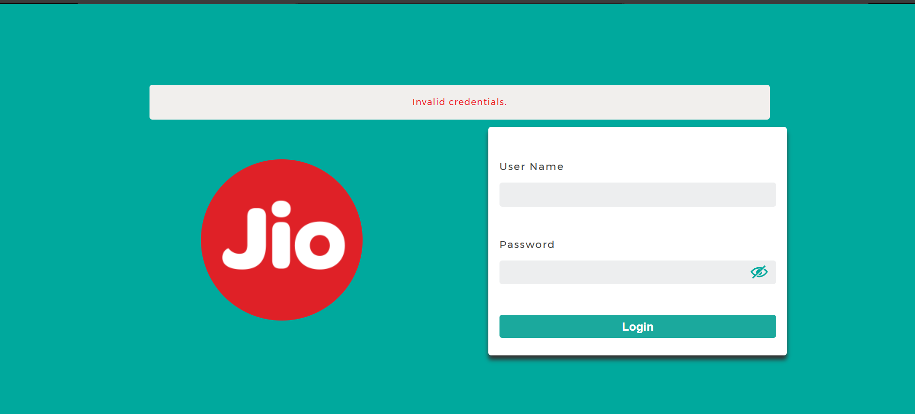

2 : Laptop's IP Address
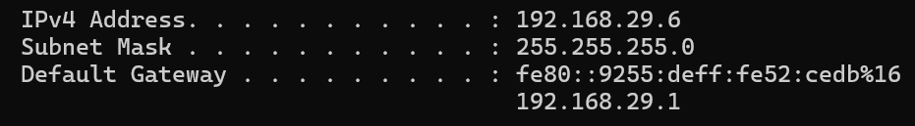

3: Static IP Configuration
I changed my laptop's IP configuration from Automatic (DHCP) to Manual (Static IP). After entering the IP address, subnet mask, default gateway, and DNS server, I tested the internet connection. Wi-Fi and internet were working successfully.
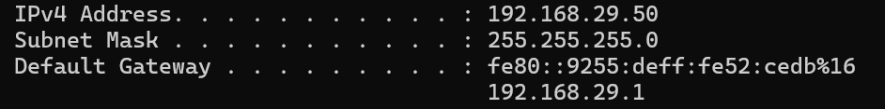

4 : DHCP Range
DHCP Range: 192.168.29.100 – 192.168.29.200
IP Address Conflict:
If two devices are assigned the same IP address on the same network, an IP address conflict occurs. Both devices may experience network connectivity problems or lose internet access until the conflict is resolved.

